Pupil premium strategy statement – Prestley Wood Academy
Before completing this template, read the Education Endowment Foundation’s guide to the pupil premium and DfE’s pupil premium guidance for school leaders, which includes the ‘menu of approaches’. It is for school leaders to decide what activity to spend their pupil premium on, within the framework set out by the menu.

This statement details our school’s use of pupil premium funding to help improve the attainment of our disadvantaged pupils.
It outlines our pupil premium strategy, how we intend to spend the funding in this academic year and the outcomes for disadvantaged pupils last academic year.

School overview
Detail | Data
Number of pupils in school | 95
Proportion (%) of pupil premium eligible pupils | 39.9%
Academic year/years that our current pupil premium strategy plan covers | 3 (24-27)
Date this statement was published | Dec 25 version
Date on which it will be reviewed | June 26
Statement authorised by | Caroline Place, Headteacher
Pupil premium lead | Mandy Walker Asst. Headteacher
Governor / Trustee lead | Squire Moorhouse

Funding overview
Detail | Amount
Pupil premium funding allocation this academic year | £ 65,460 (approximate amount due to census data on 30 new pupils not confirmed as of Dec 25)
Pupil premium funding carried forward from previous years (enter £0 if not applicable) | £0
Total budget for this academic year | £65,460

Part A: Pupil premium strategy plan

Statement of intent
Our aim is to use pupil premium funding to help us achieve and sustain positive outcomes for our disadvantaged pupils. Whilst socio-economic disadvantage is not always the primary challenge our pupils face, (we are a special school supporting young people with severe learning difficulties and profound, multiple learning difficulties all of whom have an EHCP) we do see a variance in outcomes for disadvantaged pupils across the school when compared to their peers (and those who join us at similar starting points), particularly in terms of:
• Academic attainment- expected progress or better
• Progression to further and higher education
• Employability
• Social opportunities
At the heart of our approach is high-quality teaching and targeted support focussed on areas that disadvantaged pupils require it most, targeted support based on robust diagnostic assessment of need, and helping pupils to access a broad and balanced curriculum. The school community sees developing effective communication and interaction skills being at the heart of all that we do. This, together with developing sensory and emotional regulation, can support and enable all pupils to achieve the best that they can. Although our strategy is focused on the needs of disadvantaged pupils, and most especially driven by the needs agreed by their families and a team of professionals at annual reviews of the pupil’s EHCP, it will benefit all pupils in our school where funding is spent on whole-school approaches, such as high quality teaching. Implicit in the intended outcomes detailed below, is the intention that outcomes for non-disadvantaged pupils will be improved alongside progress for their disadvantaged peers.
We will also provide disadvantaged pupils with support to develop independent life and social skills and continue to ensure that high-quality work experience, careers guidance and further education guidance is available to all. Our strategy will be driven by the needs and strengths of each young person, based on formal and informal assessments, not assumptions or labels and collaboration in annual reviews. This will help us to ensure that we offer them the relevant skills and experience they require to be prepared for adulthood.

Challenges
This details the key challenges to achievement that we have identified among our disadvantaged pupils.
Challenge number | Detail of challenge
1 | Our assessments show that disadvantaged pupils can make less progress from their starting points when entering school. Whilst the types of barriers to learning and the difficulties disadvantaged pupils experience vary, their overall academic progress can be lower across subjects compared to non-disadvantaged pupils.
2 | Our assessments, observations and discussions with pupils show that our disadvantaged pupils have language comprehension difficulties.
3 | Our assessments, observations and discussions with pupils show that disadvantaged pupils generally have challenges around communicating and expressing their needs than their peers, including non-verbal, limited language and social interaction difficulties.
4 | Through observations and conversations with pupils and their families, we find that disadvantaged pupils generally have fewer opportunities to develop cultural capital outside of school.
5 | Our assessments, observations and conversations with pupils indicate that disadvantaged pupils often require additional support to develop personal skills, e.g., independent travel.

Intended outcomes
This explains the outcomes we are aiming for by the end of our current strategy plan, and how we will measure whether they have been achieved.
Intended outcome | Success criteria
PP students (and non-disadvantaged students) make at least expected progress in literacy and numeracy. | Earwig assessment data displays progress in all areas of literacy and numeracy. (Reading, writing, number, geometry and measure) Assessment progress measured against EHCP outcomes and learning pathways
PP students (and non-disadvantaged students) improve attainment in reading | Assessment of pupils reading skills shows a reduction in the disparity in outcomes between disadvantaged pupils and their peers. This data will be gathered through diagnostic testing, phonics targeted intervention groups.
Pupils can use a range of communication systems to aid their understanding and to develop expressive communication skills. | Through achievement of EHC plan termly outcomes.
Disadvantaged pupils have greater confidence and independence to help them engage more with the wider community and prepare for adulthood. | Through observations and discussions with pupils and their families.

Activity in this academic year
This details how we intend to spend our pupil premium funding this academic year to address the challenges listed above.

Teaching (for example, CPD, recruitment and retention)
Budgeted cost: £20,000 (including leadership release time)
Activity | Evidence that supports this approach | Challenge number(s) addressed
All PP pupils have access to high quality teaching of literacy and numeracy. First-hand, high quality teaching to be achieved via increased specialist training for staff, on introduction of informal pathway as well as specialist SEND up to date training, mentoring, coaching and SEND training for specialist school for all new staff (increase of approx 20 staff every year until full PAN is achieved in 2027)  Numeracy TLR to ensure sequential, high-quality practice is embedded in the curriculum- release time, resources and network meetings for Maths hub mastery in special schools research program.  Literacy C/O to ensure DfE approved phonics scheme is embedded in the curriculum. | The DfE non-statutory guidance has been produced in conjunction with the National Centre for Excellence in the Teaching of Mathematics, drawing on evidence-based approaches: Maths_guidance_KS_1_and_2.pdf (publishing.service.gov.uk) Teaching mathematics at key stage 3 - GOV.UK (www.gov.uk)  There is strong evidence that teachers’ pedagogical and content knowledge within specific subjects has a significant impact on pupil outcomes  What-Makes-Great-Teaching-Report.pdf (suttontrust) | 1,2
School council  A school council plays a vital role in supporting pupil progress by giving students a voice in their education and school environment. Here’s how it can help:  Encouraging Leadership Skills  Improving School Environment  Representing Student Opinions  Initiating Projects & Activities  Boosting Peer Support | All of these initiatives contribute to a positive learning environment where pupils feel more engaged, supported, and empowered. We have noticed improvements on EHCP social interaction targets/ SALT targets progress among students and in the school culture. | 2,3
To develop staff understanding of communication needs. This to include training and coaching. | Regular CPD supports staff to fully understand the communication needs of their students. Evidenced by learning outcomes and communication assessment This is achieved by regular consultation, implementing feedback, SALT, whole school CPD and continuous reflection. | 1,2,3,5
A senior member of staff completed the Senior Lead Mental Health (SLMH) course means our school has expert guidance in place to support pupils’ wellbeing.  Mental Health Policies  Staff Training | Creating a Supportive School Environment – Encouraging open discussions about mental health foster a culture of understanding and reduces stigma, allowing pupils to feel safer seeking help as shown in student surveys and demonstrated in improved PSE targets. | 4,5

Targeted academic support (e.g. tutoring, one-to-one support, structured interventions)
Budgeted cost: £22,000
Activity | Evidence that supports this approach | Challenge number(s) addressed
1-1 targeted support for pupils | 2x individual boxes Tablet and cover for communication, ipad  1x communication devise ipad and AAC software training for staff and family, school uniform  1x hydro and equipment recommended by Physio  3 x sensory regulation equipment kits  3 x individuals to develop learning behaviours | 1
PP pupils to have access to planned phonic learning opportunities Focusing on core TA cost | Targeted phonic sessions in Spring and Summer term for those identified as working below expectations.  Evidence of progression seen through end of year assessments. | 2,3
Providing release time for phase leaders to focus on curriculum topics | Release time for phase leaders for topics to ensure breath and balance across NC, evidence seen through moderation of planning and lesson observations. | 4,5,6
The Twinkl Phonics Scheme is a DfE-validated systematic synthetic phonics (SSP) programme designed to support early reading and writing skills  Doodlemaths/English software pilot (Interventions for identified groups using EEF researched software used at home by families to ensure consistency. Workshops for parent/carers to use at home | Evidence seen through end of year assessment in maths, reading and phonics of progress in all areas.  Impact from family survey and data collected from software apps in pilot | 1

Wider strategies (for example, related to attendance, behaviour, wellbeing)
Budgeted cost: £ 15,000
Activity | Evidence that supports this approach | Challenge number(s) addressed
Buddy sessions weekly1 x targeted support to facilitate EHCP interaction targets, | Parent and student surveys, EHCP review discussions | 2,3
Enhancing the sensory regulation equipment available for PP learners with enhanced sensory needs, including autism. We will also fund staff training. | We have observed that sensory equipment and resources such as mattresses, lap pads, tunnels, weighted jackets and additional proprioceptor equipment can be effective at providing support for our pupils with sensory needs on a individual basis and Sensory targeted training for rebound and SI. | 3
Visiting professionals for literacy  Visiting professionals to support literacy.  Staff release time for planning and organising events. | These initiatives created a vibrant literacy culture in school, boosting confidence and enjoyment in reading as shown in student and family surveys. | 1
Bringing in specialists and hands-on experiences for scientific learning and whole school opportunities. | Expert Knowledge & Inspiration  Practical Experiments & Demonstrations  Real-World Applications  Collaborative Learning  Boosted Enthusiasm for STEM Subjects | 4,5,6
Targeted Enterprise program developing bike maintain and travel training skills | Evidence shown through student and family surveys, EHCP reviews and verbal feedback | 5
Peddles at Hinchingbrooke Country Park to promote healthy living, social interaction in the community and travel skills | Evidenced through student and family surveys, EHCP reviews and verbal feedback | 5
Targeted physical development intervention and individual regulation equine therapy | Evidenced through student and family surveys and during EHCP reviews physical recommendations and assessments. | 5

Total budgeted cost: £65,000

Part B: Review of the previous academic year(completed in summer 25)

Outcomes for disadvantaged pupils
Our internal assessment data for 24/25 demonstrates the following information:
Reception to Year 9 review of EHCP outcomes Pupil premium and LAC Number of pupils: 22
The below table displays average improvement in % for pupil premium students, non-pupil premium students and the group as a whole.
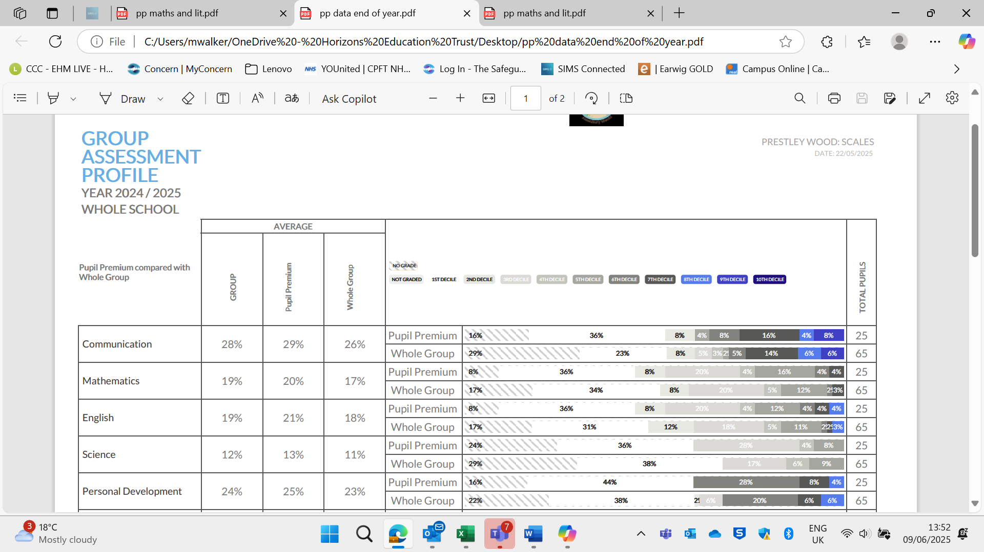

All students made expected progress on learning objectives. Pupil premium pupils made greater progress in each key indicator see above as result of academic teaching and wider interventions detailed.

Externally provided programmes
Please include the names of any non-DfE programmes that you used your pupil premium to fund in the previous academic year.
Programme | Provider
Twinkl phonics | Twinkl
Horse riding | Woodhurst Group RDA
Bike maintenance | Urban Civic Alconbury Weald

Service pupil premium funding (optional)
For schools that receive this funding, you may wish to provide the following information: How our service pupil premium allocation was spent last academic year
Educational psychologist support and assessments
Interventions small groups using EEF rated programs
Coffee morning workshops for parenting skills and support from professionals eg PinPoint
The impact of that spending on service pupil premium eligible pupils
Pupil made expected progress

Further information (optional)
Our pupil premium strategy will be supplemented by additional activity that we are not funding using pupil premium or recovery premium. That will include: • Arranging work-based learning that enables pupils to have first-hand experience of work, such as apprenticeships, traineeships, and supported internships. Planning, implementation and evaluation In planning our new pupil premium strategy, we evaluated why activity undertaken in previous years had not had the degree of impact that we had expected. We used the EEF’s families of schools database to look at the performance of disadvantaged pupils in school like ours. We contacted schools with particularly positive outcomes for disadvantaged pupils to learn from their approach. We looked at several reports, studies and research papers about effective use of Pupil Premium and the intersection between socio-economic disadvantage and SEND. We also looked at a number of studies about the impact of the pandemic on disadvantaged learners. The pandemic has also given us deeper insights into family life for those from disadvantaged backgrounds and we have been able to forge stronger relationships with parents/guardians as a result. In addition to the pupil premium funded activity outlined above, we have put in place stronger expectations around areas of effective practice, notably feedback given the impact of this identified by the EEF Toolkit. We have also put a sharp focus on supporting teachers to develop their professional practice and train in specialist areas, allowing them to develop expertise and share them with other staff. We have used the EEF’s implementation guidance to set out our plans and put in place a robust evaluation framework for the duration of our three-year approach. This will help us to make adjustments and quality improvement to secure better outcomes for pupils over time

